**CSW1 (CSE 3141) ASSIGNMENT ON NUMBERS**

**NAME:** Ashutosh Dash

**REGD. NO:** 1941012274

**SECTION:** Q

**SUBJECT:** Computer Science Workshop 1

**SEMESTER:** 3rd

**YEAR:** 2nd

**BRANCH:** CSE

**1.**

**import java.io.FileWriter;**

**import java.text.DecimalFormat;**

**import java.util.Scanner;**

**public class A5Q1 {**

**public static void main(String[] args) {**

**Scanner sc=new Scanner(System.in);**

**DecimalFormat d=new DecimalFormat("##.00");**

**System.out.println("Enter the borrowed amount (principal amount):");**

**double p=sc.nextDouble();**

**System.out.println("Enter the monthly interest rate:");**

**double i=sc.nextDouble()/12*0.01;**

**System.out.println("Enter total no.of payments you want to make:");**

**int n=sc.nextInt();**

**System.out.println(**

**"______________________________________________________________________________________________________________________________________");**

**System.out.println();**

**System.out.println(" P A Y M E N T");**

**System.out.println(**

**"______________________________________________________________________________________________________________________________________");**

**System.out.println();**

**double paymnt=( (i*p) / (1-Math.pow(1+i,-n)) );**

**System.out.println("Principal "+"Rs."+p);**

**System.out.println("Payment "+"Rs."+d.format(paymnt));**

**System.out.println("Annual Interest Rate "+(i*12*100)+"%");**

**System.out.println("Term "+ n+" month(s)");**

**System.out.println(**

**"______________________________________________________________________________________________________________________________________");**

**System.out.println();**

**System.out.println("Serial No. "+ "\t" + "Balance" + "\t" + " Interest"+ "\t"+ " Principal");**

**System.out.println(**

**"______________________________________________________________________________________________________________________________________");**

**System.out.println();**

**for(int j=1;j<=n;j++) {**

**double x=paymnt-(p*i);**

**System.out.println(j+ "\t\t\t" +d.format(p*i)+ "\t\t\t" +d.format(x)+ "\t\t\t" +d.format(p-=x));**

**}**

**System.out.println(**

**"______________________________________________________________________________________________________________________________________");**

**System.out.println();**

**System.out.println("Final Payment "+"Rs."+d.format(paymnt));**

**System.out.println(**

**"______________________________________________________________________________________________________________________________________");**

**}**

**}**

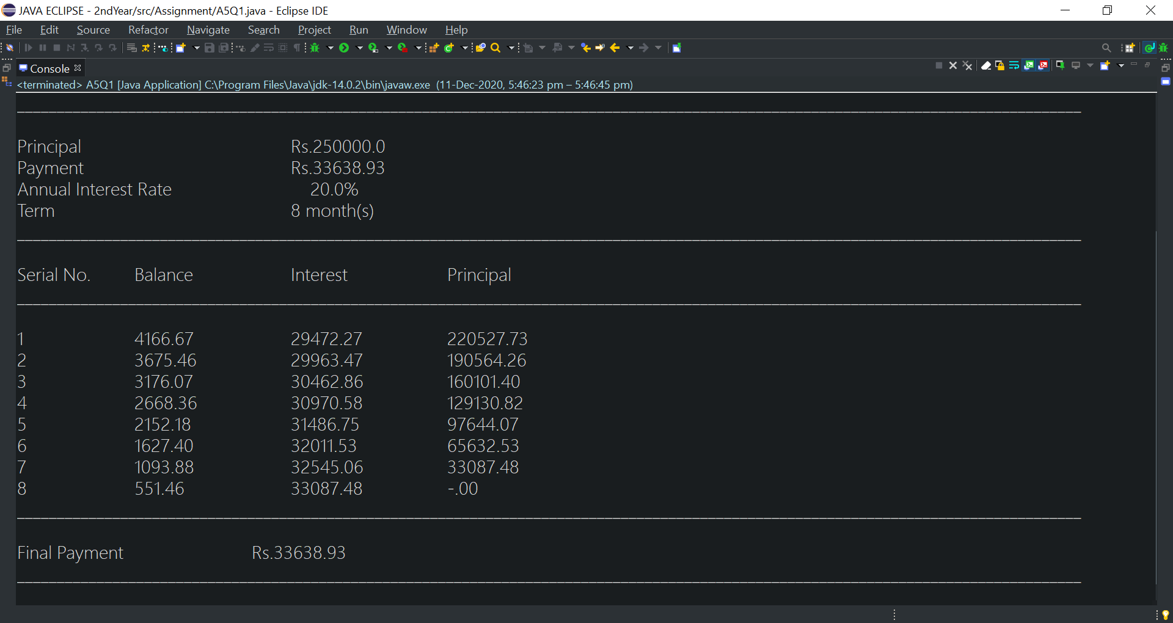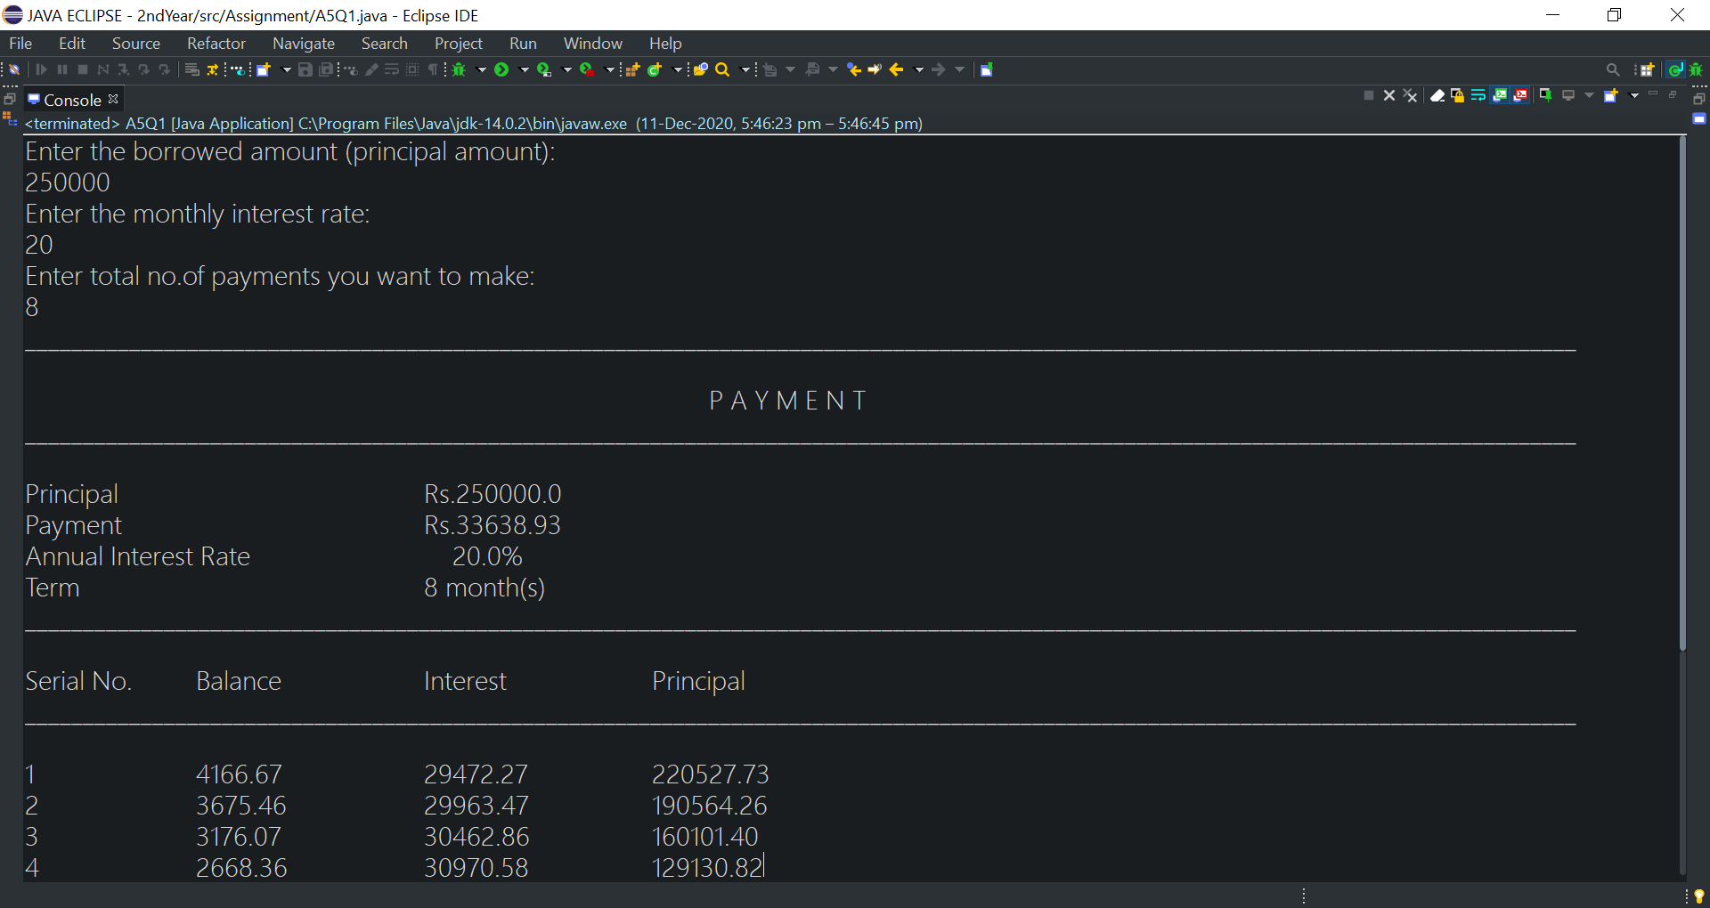

**2.**

**import java.util.Scanner;**

**public class A5Q2 {**

**public static void main(String[] args) {**

**Scanner sc=new Scanner(System.in);**

**System.out.println("Enter a number:");**

**int c=sc.nextInt();**

**System.out.println("Enter the root power:");**

**int n=sc.nextInt();**

**int cnt=0;**

**double a1,a2;**

**a2=(double)c/2;**

**do {**

**a1=a2;**

**a2=( (n-1)*a1+(c/Math.pow(a1,n-1)) )/n;**

**System.out.println("No. of step "+cnt+" value: "+a2);**

**cnt++;**

**}**

**while(Math.abs(a2-a1)>0 || cnt==99);**

**System.out.println("The Final value: ");**

**System.out.printf("%.2f",a2);**

**}**

**}**

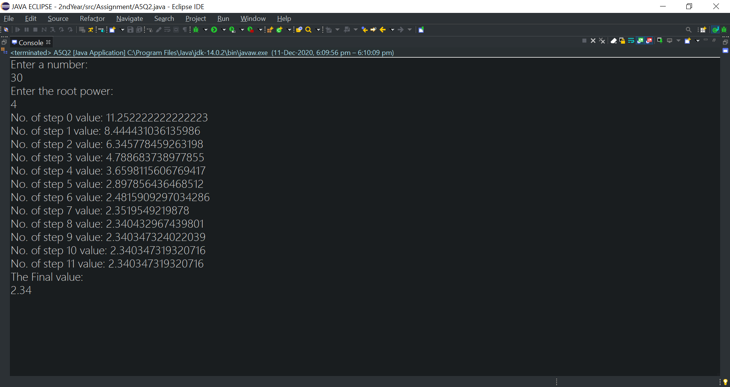

**3.**

**public class A5Q3 {**

**public static void main(String[] args) {**

**if(args.length<2)**

**System.out.println("The program requires two command line arguments");**

**else {**

**int sum=0;**

**for(int i=0;i<args.length;i++)**

**sum=Integer.parseInt(args[i]);**

**System.out.println(sum);**

**}**

**}**

**}**

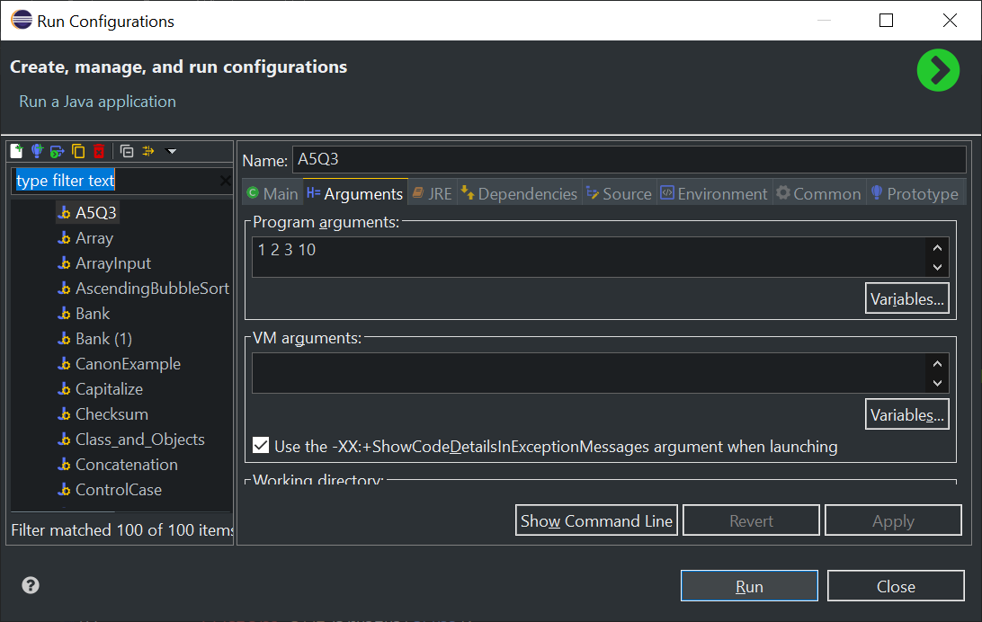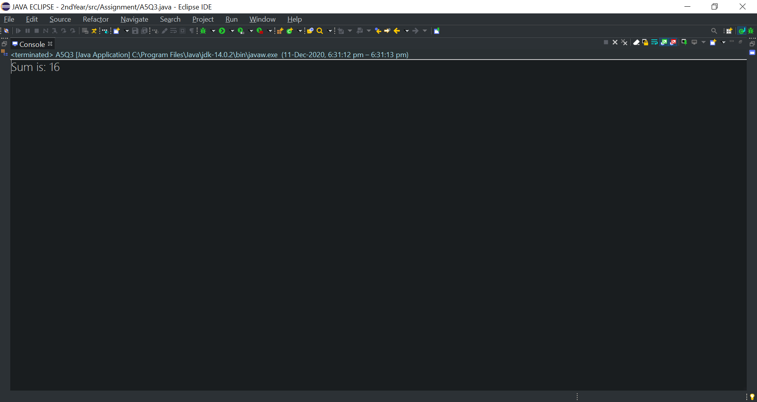

**4.**

**import java.text.DecimalFormat;**

**import java.text.NumberFormat;**

**public class A5Q4 {**

**public static void main(String[] args) {**

**if(args.length<2)**

**System.out.println("The program requires two command line arguments");**

**else {**

**double sum=0;**

**for(int i=0;i<args.length;i++)**

**sum+=Double.parseDouble(args[i]);**

**DecimalFormat d=new DecimalFormat(".00");**

**System.out.println("Sum is: "+d.format(sum));**

**}**

**}**

**}**

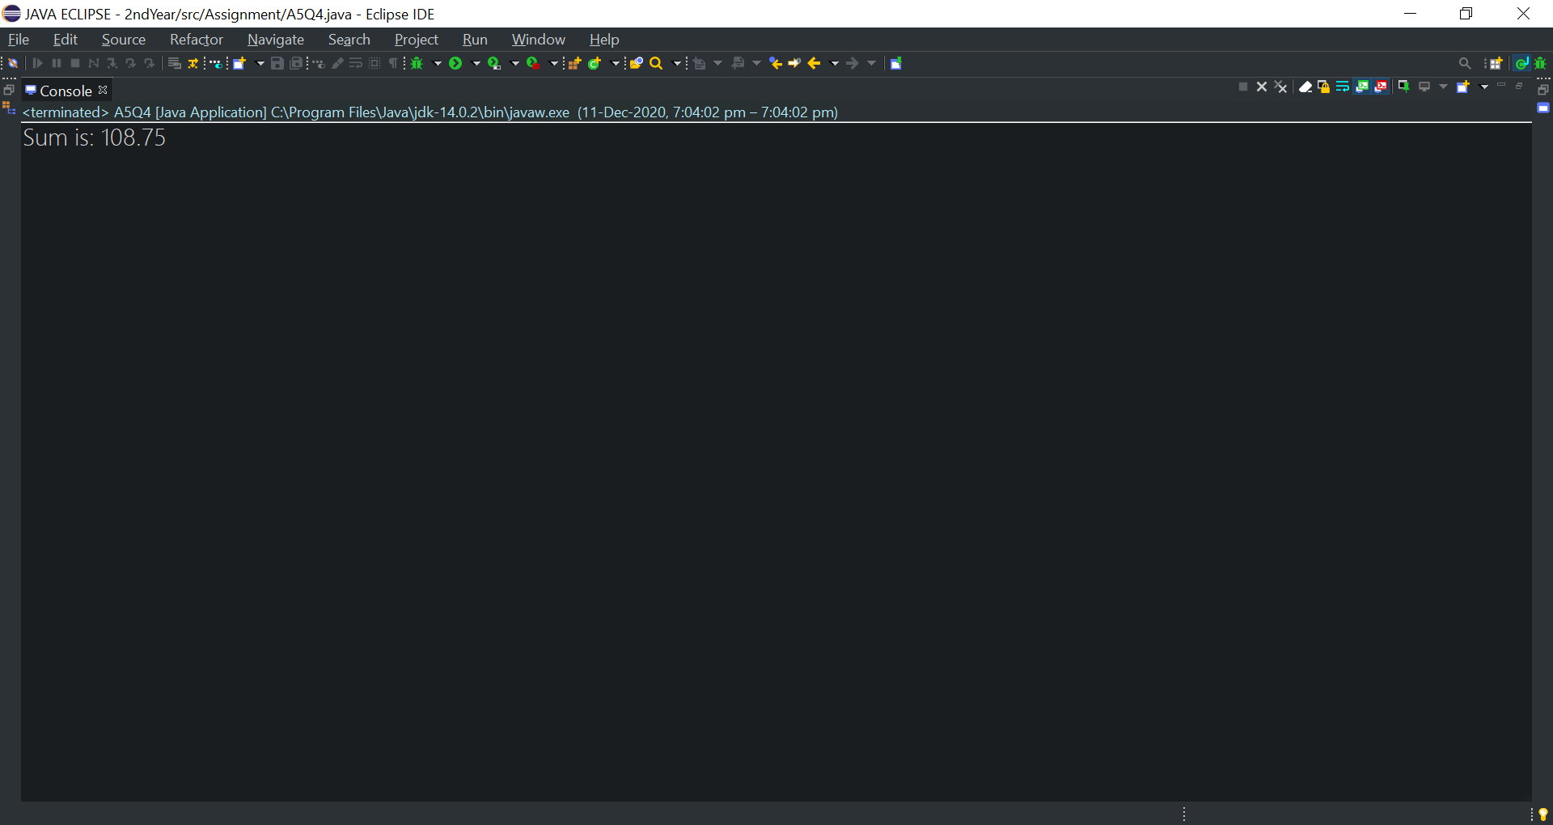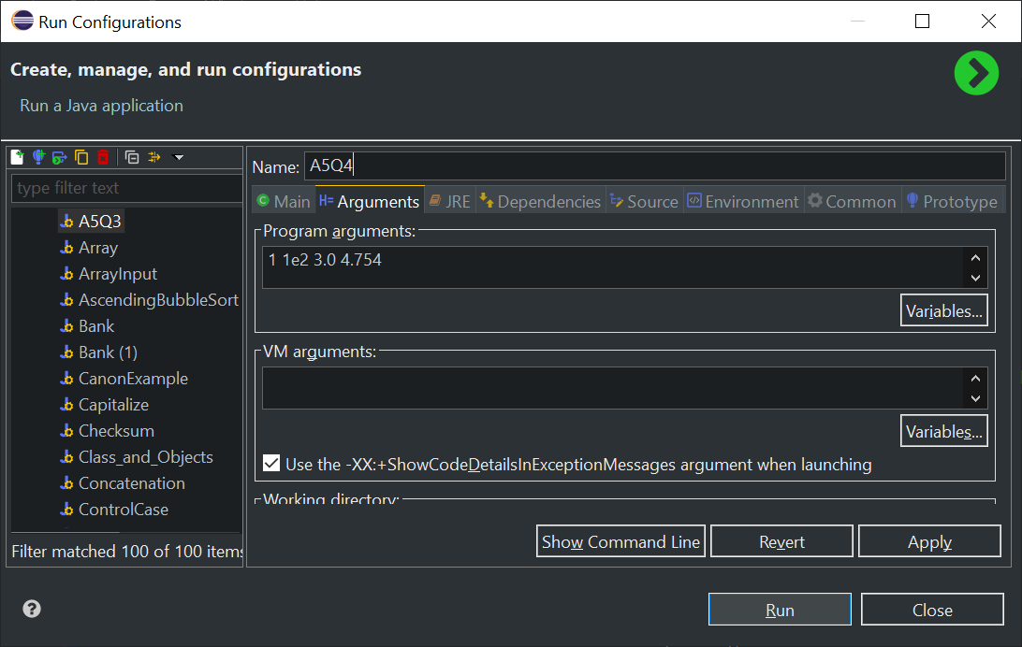

**import java.util.Scanner;**

**5.**

**public class A5Q5 {**

**public static void main(String[] args) {**

**Scanner sc=new Scanner(System.in);**

**System.out.println("Enter a no. to check if its pallindrome or not:");**

**int rev,sum=0,temp;**

**int num=sc.nextInt();**

**temp=num;**

**while(num>0) {**

**rev=num%10;**

**sum=(sum*10)+rev;**

**num=num/10;**

**}**

**if(temp==sum)**

**System.out.println(temp+" is a palindrome number ");**

**else**

**System.out.println(temp+" is not a palindrome");**

**}**

**}**

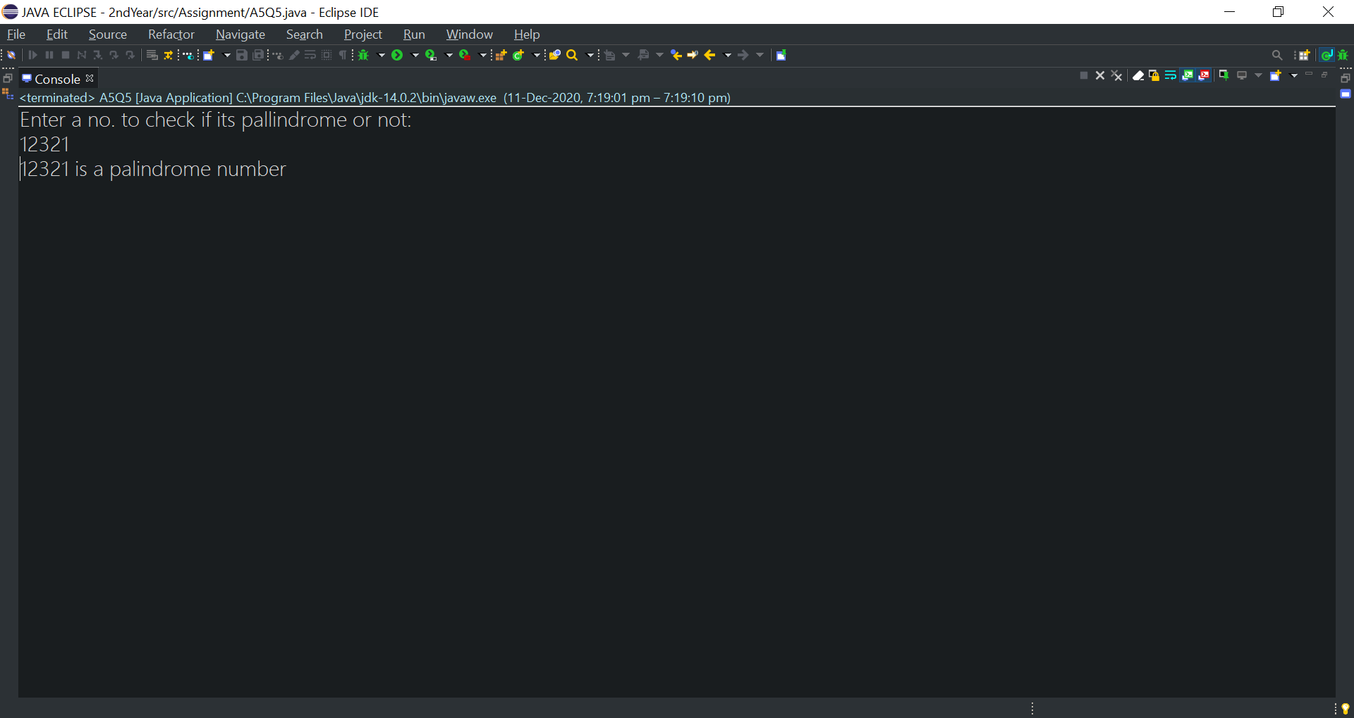 **import java.text.DecimalFormat;**

**6.**

**import java.text.NumberFormat;**

**public class A5Q6 {**

**public static void main(String[] args) {**

**System.out.println("FAHRENHEIT"+ "\t\t\t" +"CELSIUS");**

**System.out.println("_______________________________________________________");**

**double celsius;**

**for(int fahrenheit=-40;fahrenheit<=120;fahrenheit+=10) {**

**celsius=(5d/9d)*(fahrenheit-32);**

**NumberFormat n=new DecimalFormat(".##");**

**System.out.println(fahrenheit+ " " +n.format(celsius));**

**}**

**}**

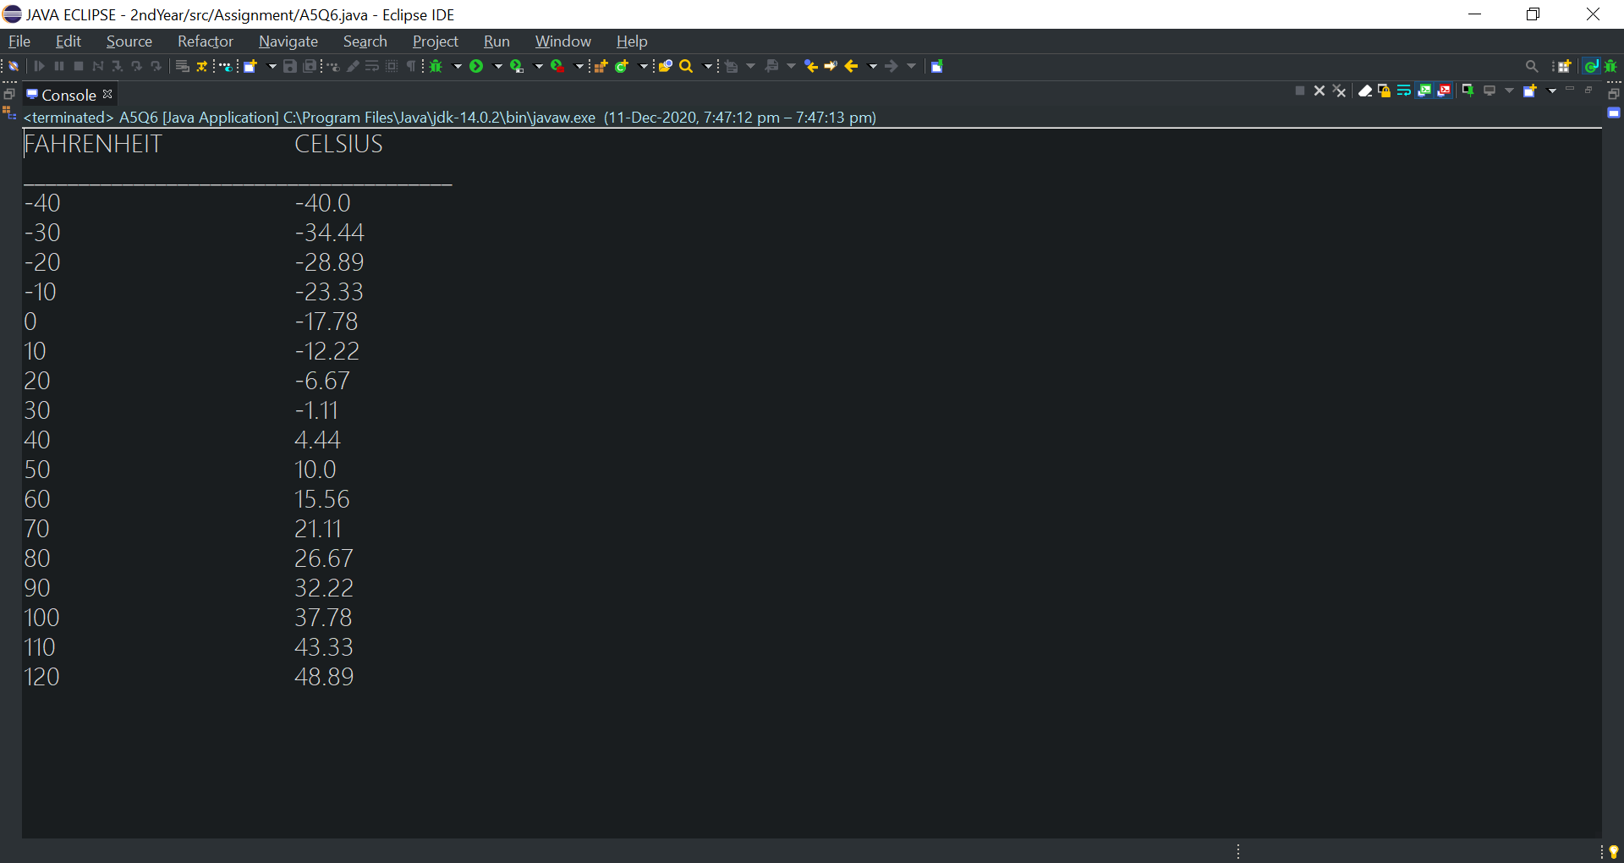**}**

**7.**

**import java.util.Scanner;**

**public class A5Q7 {**

**public static void main(String[] args) {**

**Scanner sc=new Scanner(System.in);**

**System.out.println("Enter a number:");**

**int num = sc.nextInt(), r= 0;**

**int p=num;**

**while(num != 0) {**

**int d=num % 10;**

**r = r* 10 + d;**

**num /= 10;**

**}**

**System.out.println("Reversed Number: " + r);**

**int s=p+r;**

**System.out.println("we have to check if their sum "+s+" is pallindrome or not:");**

**int rev,sum=0,temp;**

**temp=s;**

**while(s>0) {**

**rev=s%10;**

**sum=(sum*10)+rev;**

**s=s/10;**

**}**

**if(temp==sum)**

**System.out.println(temp+ " is a palindrome number ");**

**else**

**System.out.println(temp+ "is not palindrome");**

**}**

**}**

